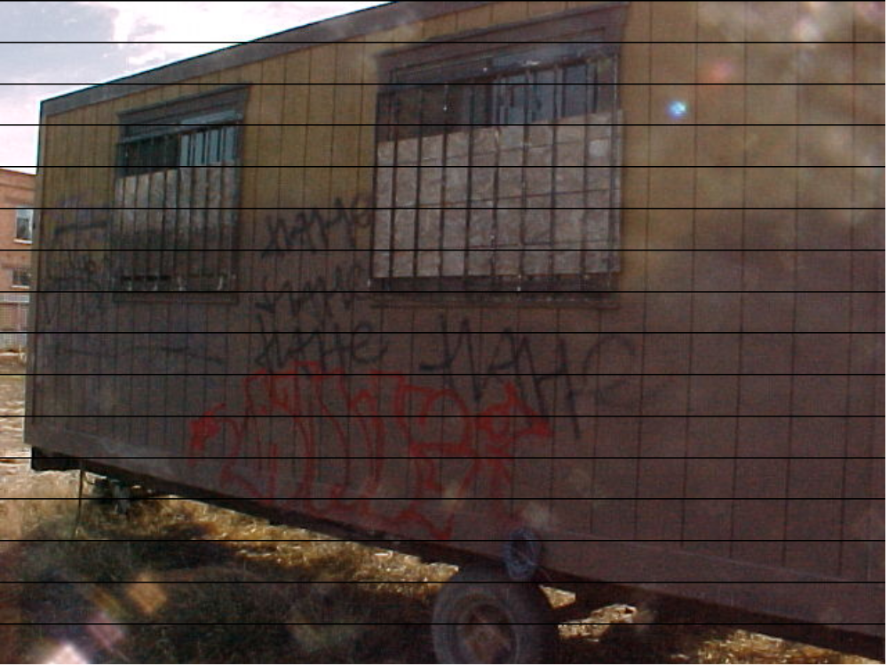

GRAFFITI PICTURE #3

